**FLUID & IT’S PROPERTIES**

**EFIPCC91A**. To what change in pressure a liquid of specific gravity 1.2 should be subjected to cause reduction in volume by one per cent? The velocity of sound in the liquid is 1500 m/s. **[Ans 27 MPa]**

**EFIPCC06A**. A plate with surface area of 0.4 m2 and weight of 500 N slides down on an inclined plane 300 to the horizontal at a constant speed of 4 m/s. If the inclined plane is lubricated with an oil of dynamic viscosity is 2 poise, find the thickness of lubricant film. **[Ans 1.28 mm]**

**EFIPCC07A**. A rotating viscometer has two cylinders. The radius of inner fixed cylinder is R1 and the radius of the outer rotating cylinder is R2. This viscometer is used for the measurement of viscosity. Derive an expression for the viscosity in terms of the torque acting on the inner cylinder of height L, gap between the bottoms of the two cylinders, b and the angular speed ω (omega)

**EFIPCC08A.** Through a very narrow gap of height ‘h’ a thin plate of large extent is pulled at a velocity V. on one side of viscosity μ1 and on other side oil viscosity μ2. Calculate the position of plate so that:

i) The shear force on two sides of plate is equal

ii) The pull required to drag the plate is minimum

**EFIPCC12A.** A vertical gap 23.5 mm wide of infinite extent contains oil of specific gravity 0.9 and viscosity 2.5 N-s/m2. A metal plate 1.5 m × 1.5 m × 1.5 mm weighing 50 N is to be lifted through the gap at a constant speed of 0.1 m/sec. Estimate the force required to lift the plate:  **[Ans 122.47485 N]**

**EFIPCC13A**. The velocity distribution for flow over a plate is given by u = 2y – y2 in which u is the velocity in ms-1 at a distance y meters from the plate. Determine the shear stress in N /m2 at the boundary and at 0.2 m from it. Dynamic viscosity of fluid is 0.9 Ns/m2  **[Ans 1.8N/m2 , 1.44 N/mm2 ]**

**EFIPCC14A**. A rectangle plate of 0.50 m × 0.50 m dimensions weighing 500 N slides down an inclined plane making 300 angle with the horizontal, at a velocity of 1.75 m/s. If the 2 mm gap between the plate and the inclined surface is filled with a lubricating oil, find its viscosity and express it in poise as well as in Ns/m2. [**Ans 1.1428N-s/m2 , 11.428 Poise]**

**EFIPMC00A**. A solid cone of radius r0, and vertex angle 2θ is to rotate at an angular velocity ω. An oil of viscosity μ and thickness fills the gap between the cone and the housing. Determine the torque T required to rotate the cone.

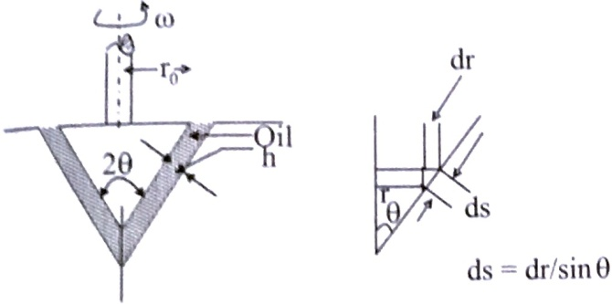

**EFIPMC11A**. A hydraulic lift of the type commonly used for greasing automobiles consists of a 280 mm diameter ram that slides in a 280.18 mm cylinder. The annular space between the ram and cylinder is filled with oil having a kinematic viscosity of 0.00042 m2/s and specific gravity of 0.86. If the rate of travel of the ram is 0.22 m/s, find the frictional resistance when 2 m of the ram is engaged in the cylinder. **[Ans 1.525 kN]**